**SPEECH THERAPY ASSESSMENT FOR CHILDREN**

**ABSTRACT:** Autism Spectrum Disorder (ASD) is a developmental disability caused by differences in the brain. Children with ASD may avoid eye contact, repeat actions like turning around themselves. We are presenting one solution in the form of a mobile application which includes development of teaching and learning aid using articulatory phonetics in regional language (Marathi). The main aim of this application is to help the society using the recent technologies like Android which will also be a huge help to the medical industry.

So, to achieve the objective we will be making a mobile phone application which will be user-friendly and will be effective in achieving the desired outcome. The application will have a good user-interface which will make it easy for the parent and the child to use it. It will consist of an admin part where the admin can add the category to the existing category of letters in Marathi language. Likewise, the admin can delete or modify the same. Similarly, the admin can add, delete, update the words and audio associated with a specific category of letters also he can add questions for the assessment. The main feature of our app is that along with the learning methodology our app will also consist of assessment section, so that we can access the progress of the children. The user will be able to choose a category of words and then clicking on the words will produce the audio pertaining that word.

By this application children can learn new words and parents themselves can monitor their child’s progress without having to go to the doctor personally each time. Its ease of use and accessibility impacts and benefits both the child and the doctor.

***Keywords****: ASD, autism, app development, react-native, speech therapy*

**INTRODUCTION:** AAC stands for Augmentative and Alternative Communication. It is a set of tools and strategies used to support or replace spoken language for people with communication difficulties. AAC can include a range of methods, from simple picture cards to complex electronic devices, that allow individuals to express themselves and participate in social interactions.

AAC can benefit individuals with a variety of conditions, including autism, cerebral palsy, Down syndrome, and aphasia. The goal of AAC is to help individuals communicate effectively and participate in daily life activities, such as expressing needs and preferences, making choices, socializing with others, and participating in academic or vocational settings. AAC can also improve overall quality of life by reducing frustration, increasing independence, and promoting self-esteem.

The **need of the proposed system** can be highlighted based on the following factors:

Ambiguity in Autism treatment: The lack of clear symptoms in Autism results in a lack of a definitive treatment approach. The available treatments depend on specific symptoms.

Underutilization of technology: Despite the thriving technology sector, there is a substantial untapped potential for technology in the medical industry for treating Autism.

Remote monitoring convenience: The proposed mobile application provides the convenience of remote monitoring, allowing parents and to track their child's progress without requiring a doctor's visit.

**LITERATURE SURVEY**

|  |  |
| --- | --- |
| **Existing**  **Applications** | **Key points** |
| Proloquo2go | * Only for ios users. * Language supported: English, Dutch, French and Spanish. * Not intended for children, intended for teenagers. * It is paid application. |
| Sonoflex | * Only for ios users. * Only English language is supported. * App is complex because it is integrated other assistive technologies, such as hearing aids and cochlear implants. * It is very heavy app (333 mb in size). * Paid application. |
| Card talk | * Available on both app store and play store. * English and Japanese language supported. * No login is required. * user-friendly interface. * Users have permission to record audio. * It is free application. * No assessment methodology available. |
| Jellow basic | * Available on both app store and play store. * English, Hindi, and Bengali language supported. * Login is required. * No option to record audio * It is a free application. * No assessment methodology available. |

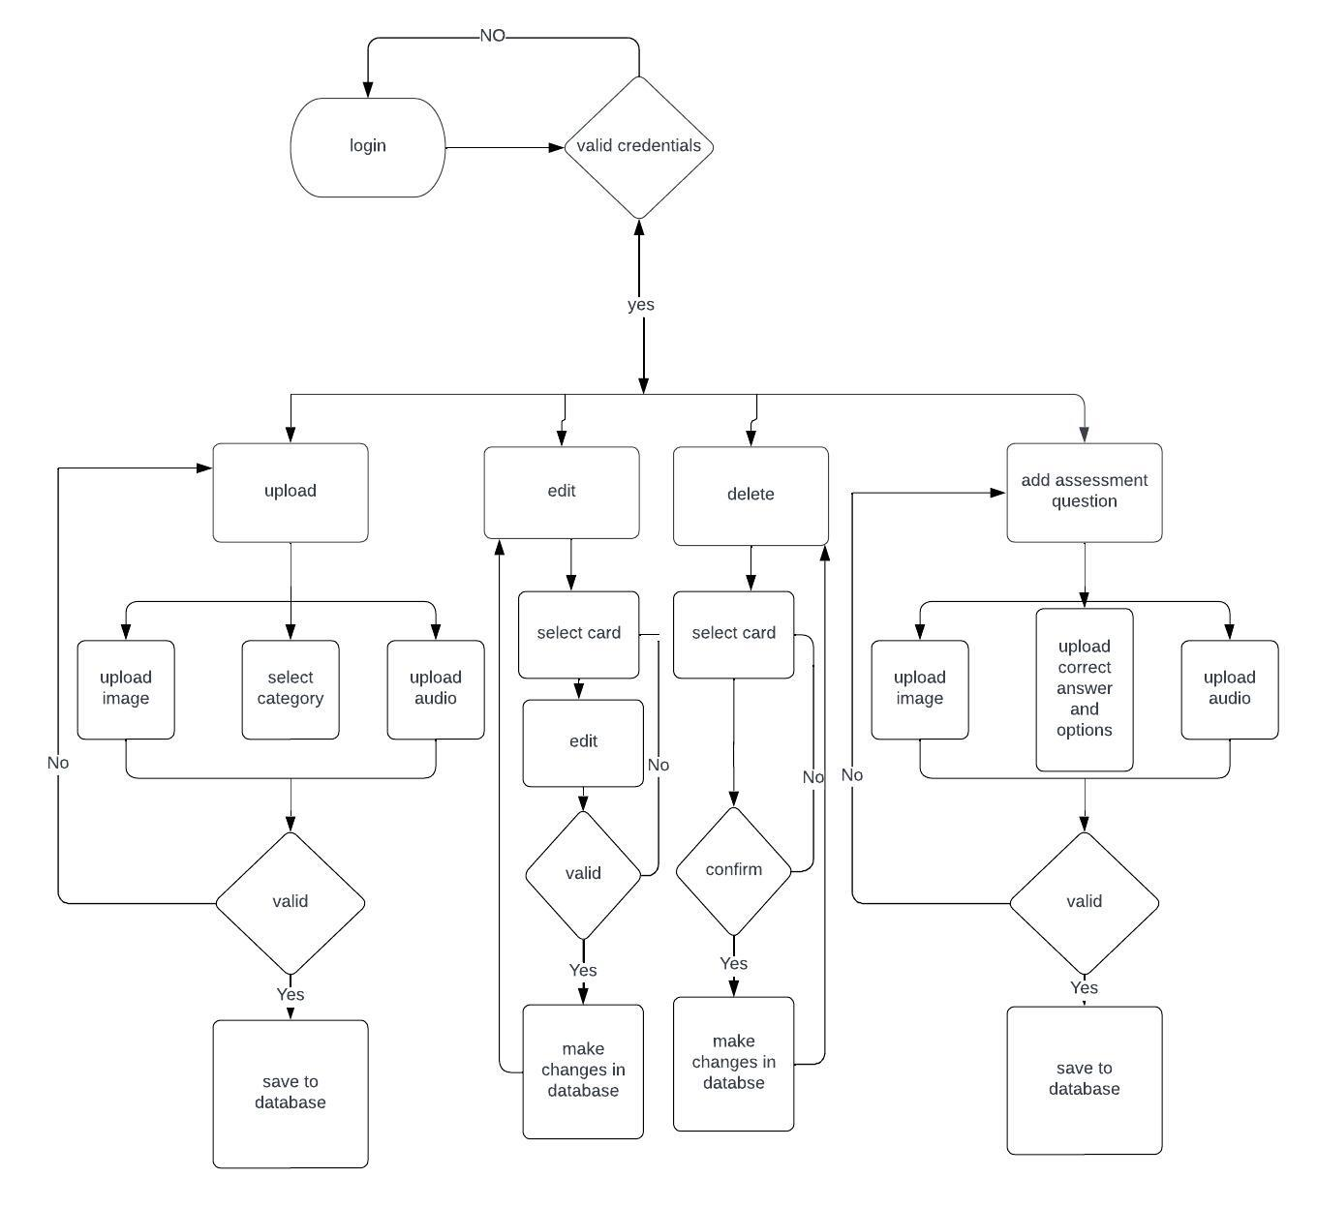**ADMIN SIDE**

The admin has various functionalities available to them on the application's back-end:

* They can add new cards to a specific category, modify existing cards, and remove cards from a category.
* Additionally, the admin can create a new category for cards, modify an existing category, or delete a category altogether.
* The admin also has the ability to change their login password and log out of the application.
* The admin can also add assessment questions in MCQ format along with all the options and correct answer.

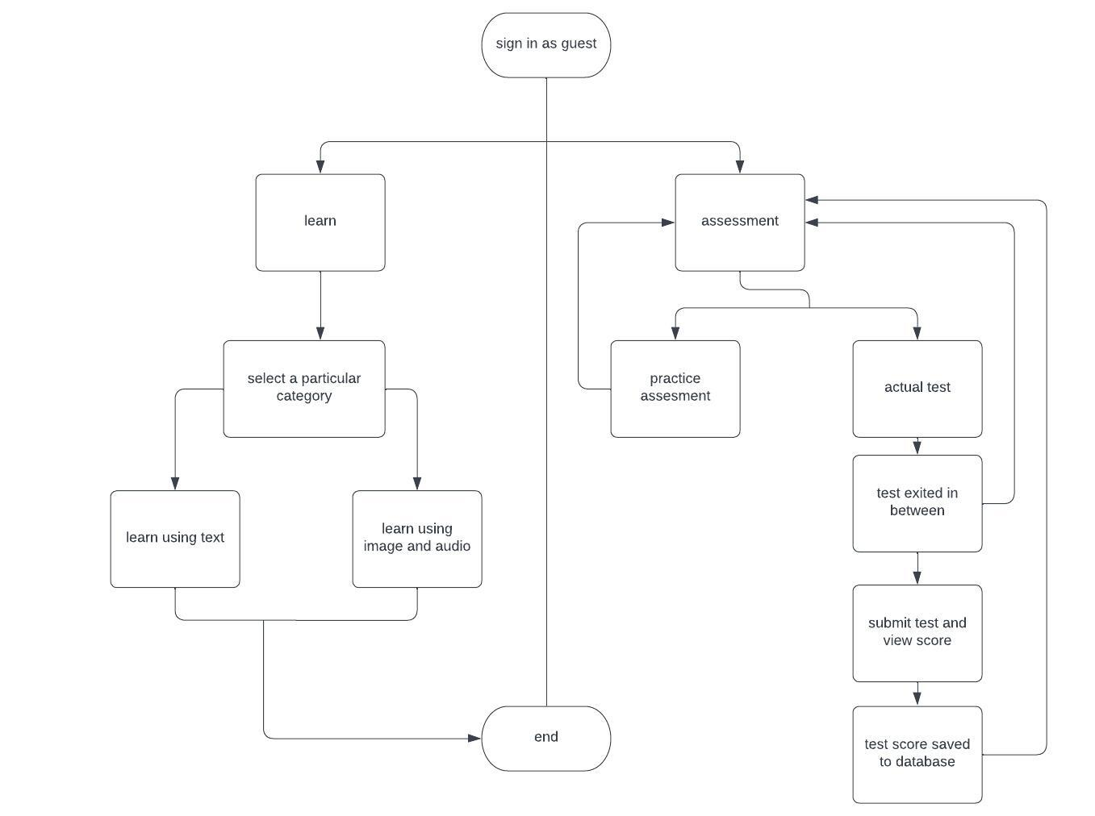**USER SIDE**

The user is not required to log in to access the application. Once they have access, the user can view cards belonging to a particular category and listen to the audio pronunciation of each card. Once the user has enough practice than (s)he can give assessment to track their progress.